
Prediction of Insurance Charges
The goal of this study is to train a model in order to predict insurance charges. The dataset used in this case study, which can be found in https://www.kaggle.com/datasets/thedevastator/prediction-of-insurance-charges-using-age-gender/data, has 8 features and 1338 samples. It contains detailed information about insurance customers including their age, sex, body mass index (BMI), number of children, smoking status and region. Having access to such valuable information allows analysts to get a better view into customer behavior and the factors that contribute to their insurance charges.
Isalos version used: 2.0.6

Step 1: Import data from file
Right click on the input spreadsheet (left) and choose the option “Import from File”. Then navigate through your files to load the one with the insurance charges data.

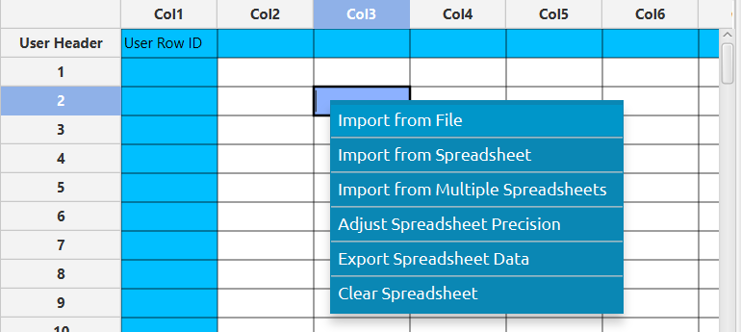

The data will appear on the left spreadsheet.
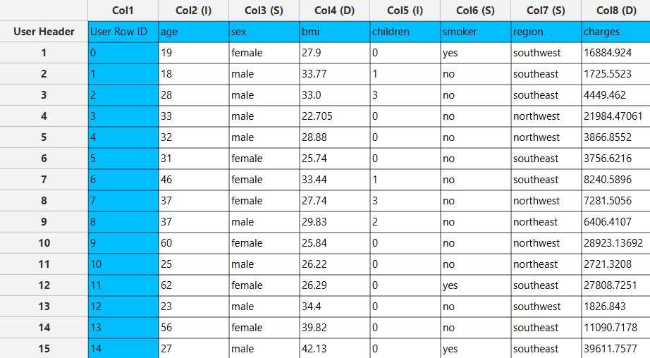

Step 2: Manipulate data
In this dataset there are not any empty values, so we can select all the columns to be used. On the menu click on Data Transformation $→$ Data Manipulation $→$ Select Column(s) and select all columns.
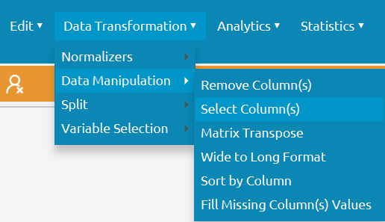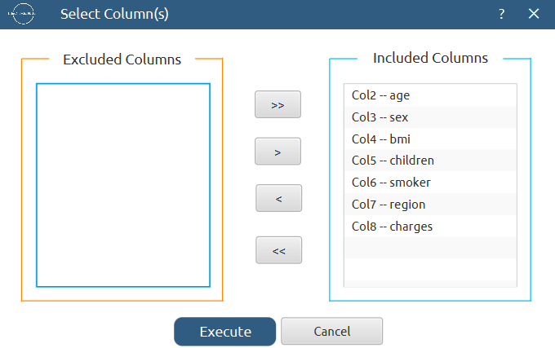

All of the data will appear in the output (right) spreadsheet. This tab can be renamed “IMPORT” by right-clicking on it and choosing the “Rename” option.
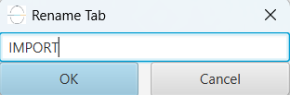

Step 3: Split data
Create a new tab by pressing the “+” button on the bottom of the page with the name “TRAIN_TEST_SPLIT” which we will use for splitting the train and test set.
Import data into the input spreadsheet of the “TRAIN_TEST_SPLIT” tab from the output of the “IMPORT” tab by right-clicking on the input spreadsheet and then choosing “Import from Spreadsheet”.

Split the dataset by choosing Data Transformation $→$ Split $→$ Random Partitioning. Then choose the “Training set percentage” and the column for the sampling as shown below:
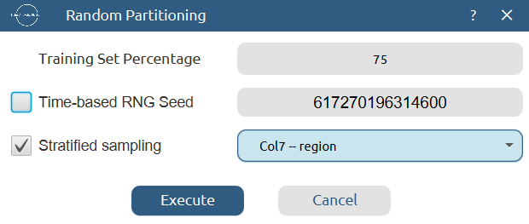

The results will be two separate spreadsheets, “TRAIN_TEST_SPLIT: Training Set” and “TRAIN_TEST_SPLIT: Test Set”, which will be available to import into the next tabs.

Step 4: Normalize the training set
Create a new tab by pressing the “+” button on the bottom of the page with the name “NORMALIZE_TRAIN_SET”.
Import into the input spreadsheet of the “NORMALIZE_TRAIN_SET” tab the train set from the output of the “TRAIN_TEST_SPLIT” tab by right-clicking on the input spreadsheet and then choosing “Import from Spreadsheet”. From the available Select input tab options choose “TRAIN_TEST_SPLIT: Training Set”.
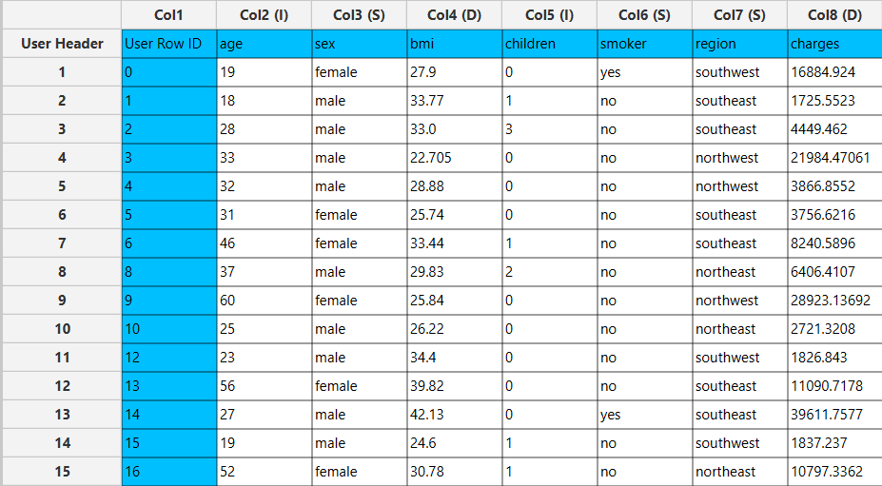

Normalize the data using Z-score: Data Transformation $→$ Normalizers $→$ Z Score and select all columns except the “charges” target column.
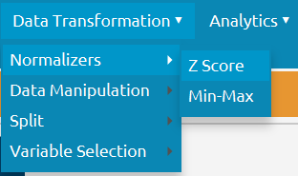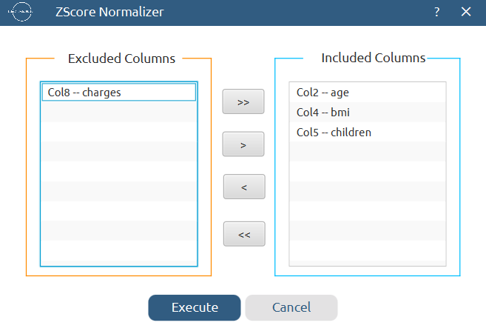

The results will appear on the output spreadsheet.
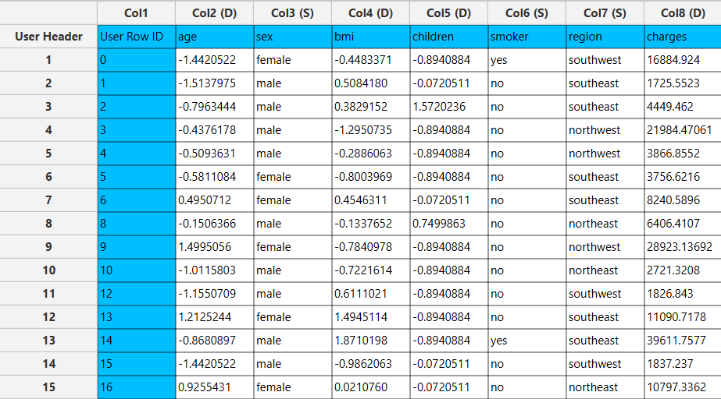

Step 5: Normalize the test set
Create a new tab by pressing the “+” button on the bottom of the page with the name “NORMALIZE_TEST_SET”.
Import into the input spreadsheet of the “NORMALIZE_TEST_SET” tab the test set from the output of the “TRAIN_TEST_SPLIT” tab by right-clicking on the input spreadsheet and then choosing “Import from Spreadsheet”. From the available Select input tab options choose “TRAIN_TEST_SPLIT: Test Set”.

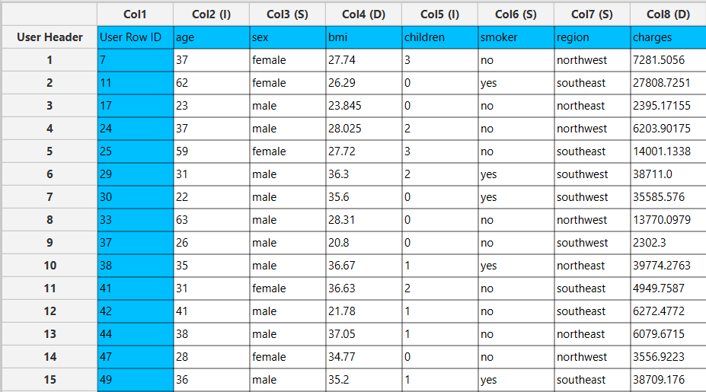

Normalize the test set using the existing normalizer of the training set: Analytics $→$ Existing Model Utilization $→$ Model (from Tab:) NORMALIZE_TRAIN_SET

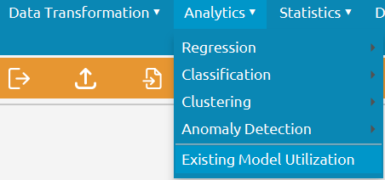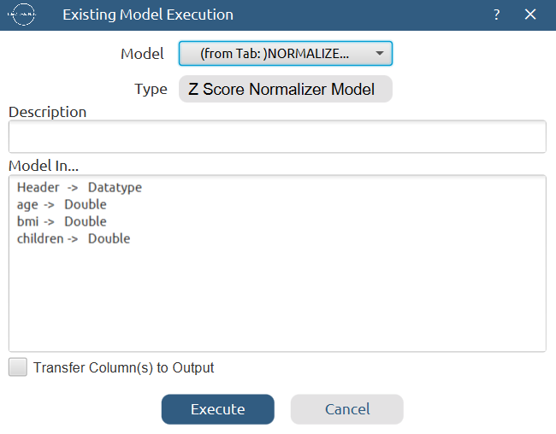

The results will appear on the output spreadsheet.
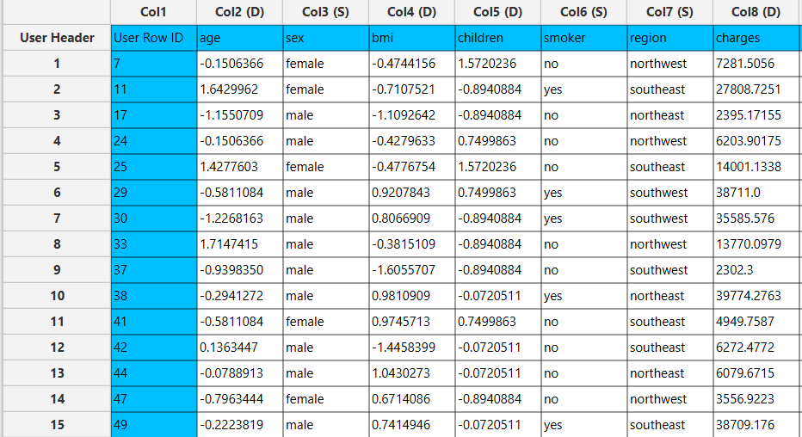

Step 6: Feature selection
Create a new tab by pressing the “+” button on the bottom of the page with the name “FEATURE_SELECTION_REGRESSION”.
Import data into the input spreadsheet of the “FEATURE_SELECTION_REGRESSION” tab from the output of the “NORMALIZE_TRAIN_SET” tab by right-clicking on the input spreadsheet and then choosing “Import from Spreadsheet”.
Then do regression analysis with the “charges” column as the intercept: Data Transformation $→$ Variable Selection $→$ Regression Analysis
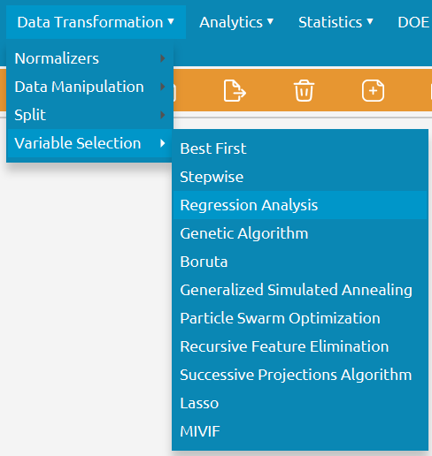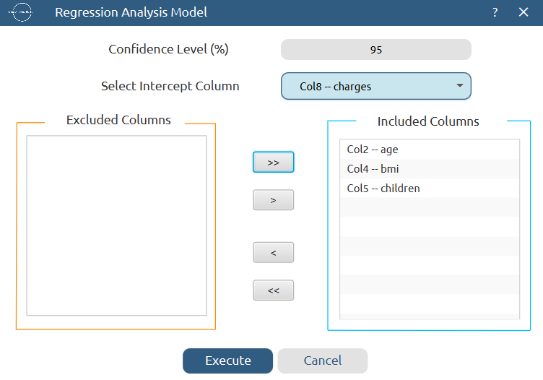
The results will appear on the right spreadsheet.
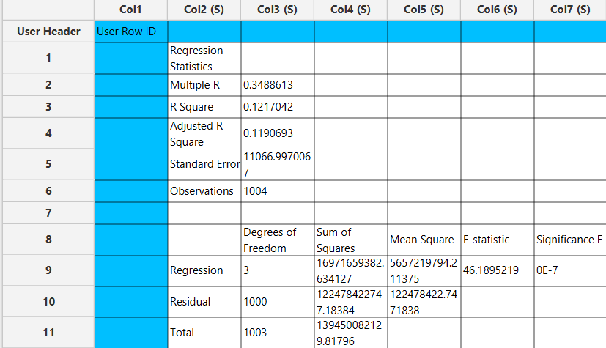

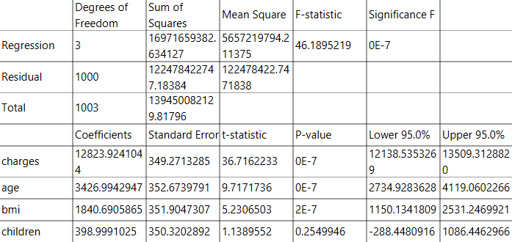

The significant numerical features according to the p-value are the following:
- age (p-value = 0E-7)
- bmi (p-value = 2E-7)

Step 7: Feature selection: Train set
Create a new tab by pressing the “+” button on the bottom of the page with the name “FEATURE_SELECTION_TRAIN_SET”.
Import data into the input spreadsheet of the “FEATURE_SELECTION_TRAIN_SET” tab from the output of the “NORMALIZE_TRAIN_SET” tab by right-clicking on the input spreadsheet and then choosing “Import from Spreadsheet”.
Manipulate the data by choosing the columns that correspond to the significant features (as indicated by the previous step) by browsing: Data Transformation → Data Manipulation → Select Column(s)

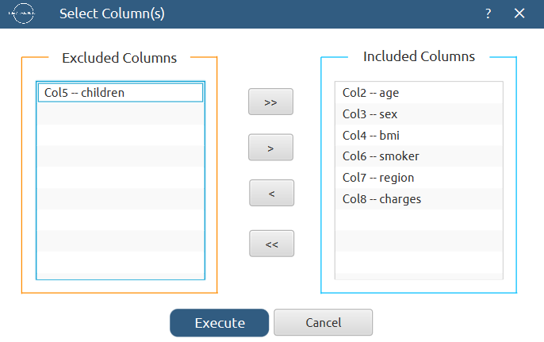

The results will appear on the output spreadsheet.
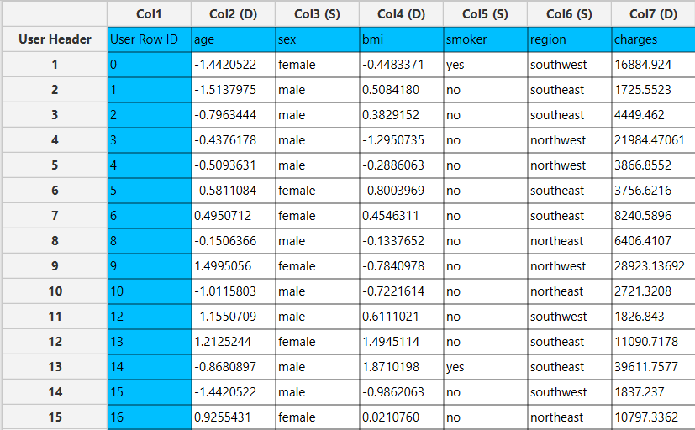

Step 8: Feature selection: Test set
Create a new tab by pressing the “+” button on the bottom of the page with the name “FEATURE_SELECTION_TEST_SET”.
Import data into the input spreadsheet of the “FEATURE_SELECTION_TEST_SET” tab from the output of the “NORMALIZE_TEST_SET” tab by right-clicking on the input spreadsheet and then choosing “Import from Spreadsheet”.
Manipulate the data by choosing the columns that correspond to the significant features by browsing: Data Transformation → Data Manipulation → Select Column(s)

The results will appear on the output spreadsheet.
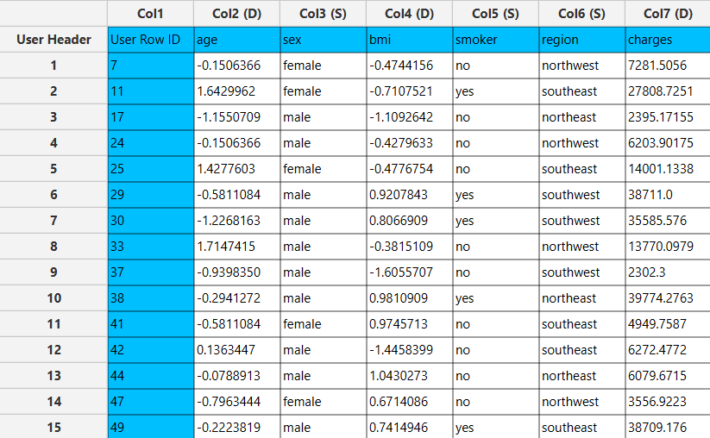

Step 9: Train the model
Create a new tab by pressing the “+” button on the bottom of the page with the name “TRAIN_MODEL(.fit)”.
Import data into the input spreadsheet of the “TRAIN_MODEL(.fit)” tab from the output of the “FEATURE_SELECTION_TRAIN_SET” tab by right-clicking on the input spreadsheet and then choosing “Import from Spreadsheet”.
Use the k-Nearest Neighbors (kNN) method to train and fit the model: Analytics $→$ Regression $→$ k-Nearest Neighbors (kNN)

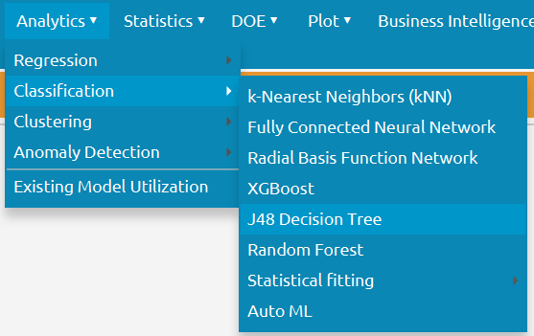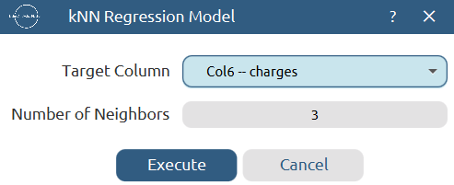

The predictions will appear on the output spreadsheet.
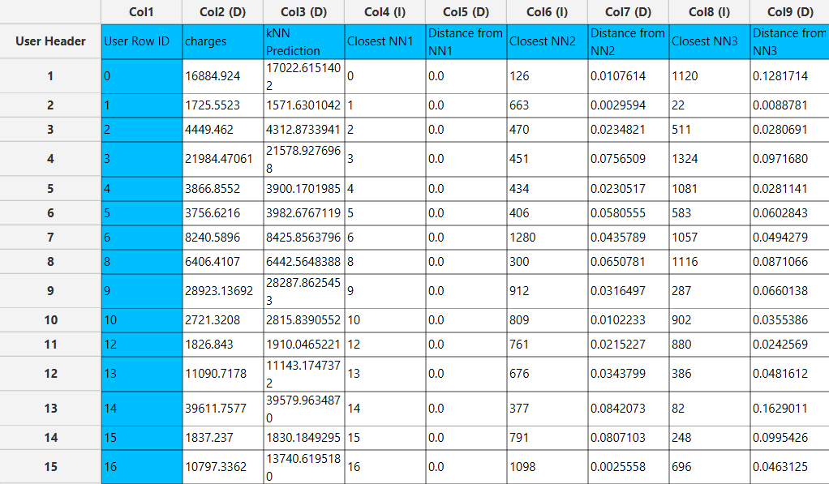

Step 10: Validate the model
Create a new tab by pressing the “+” button on the bottom of the page with the name “VALIDATE_MODEL(.predict)”.
Import data into the input spreadsheet of the “VALIDATE_MODEL(.predict)” tab from the output of the “FEATURE_SELECTION_TEST_SET” tab by right-clicking on the input spreadsheet and then choosing “Import from Spreadsheet”.
To validate the model: Analytics $→$ Existing Model Utilization$→$ Model (from Tab:) TRAIN_MODEL(.fit). Choose the column “charges” to be transferred to the output spreadsheet.
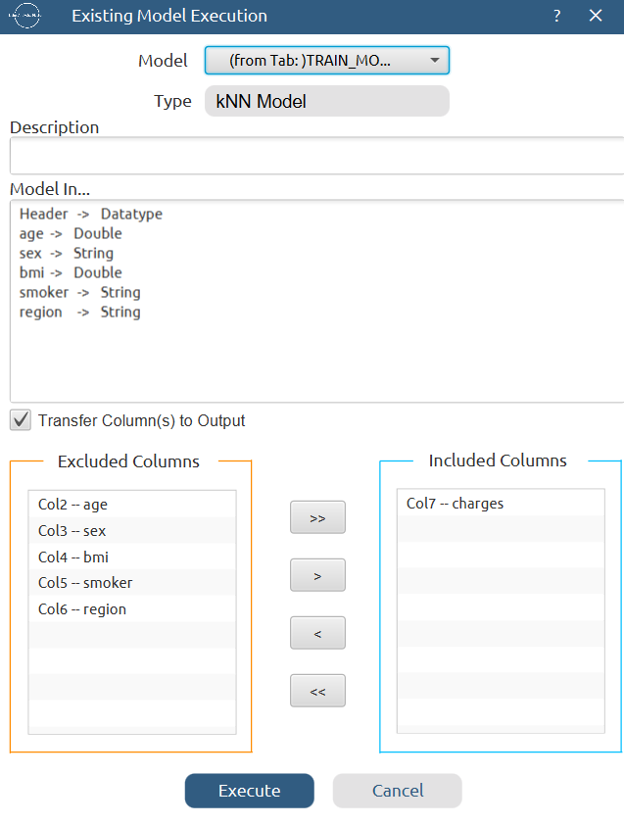

The predictions will appear on the output spreadsheet.
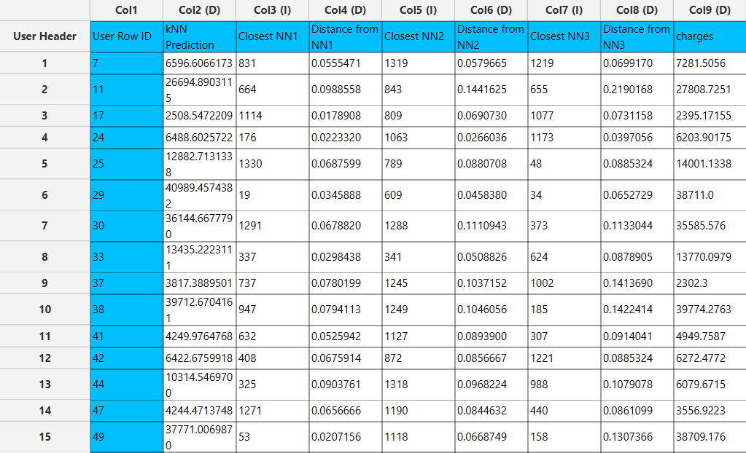

Step 11: Statistics calculation
Create a new tab by pressing the “+” button on the bottom of the page with the name “STATISTICS_ACCURACIES”.
Import data into the input spreadsheet of the “STATISTICS_ACCURACIES” tab from the output of the “VALIDATE_MODEL(.predict)” tab by right-clicking on the input spreadsheet and then choosing “Import from Spreadsheet”.
Calculate the statistical metrics for the regression: Statistics $→$ Model Metrics $→$ Regression Metrics

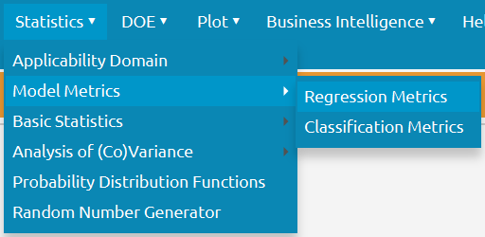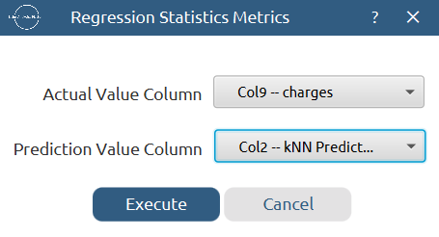

The results will appear on the output spreadsheet.
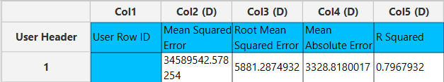

Step 12: Reliability check for each record of the test set

Step 12.a: Create the domain
Create a new tab by pressing the “+” button on the bottom of the page with the name “EXCLUDE_CHARGES”.
Import data into the input spreadsheet of the “EXCLUDE_CHARGES” tab from the output of the “FEATURE_SELECTION_TRAIN_SET” tab by right-clicking on the input spreadsheet and then choosing “Import from Spreadsheet”.
Manipulate the data to exclude the target column “charges”: Data Transformation $→$ Data Manipulation $→$ Select Column(s)
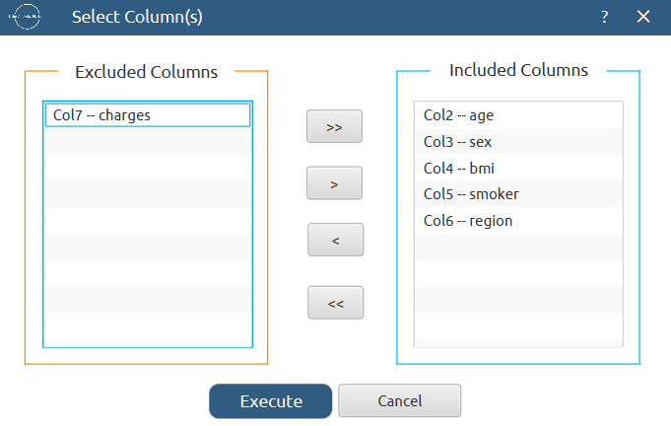

The results will appear on the output spreadsheet.
Create a new tab by pressing the “+” button on the bottom of the page with the name “DOMAIN”.
Import data into the input spreadsheet of the “DOMAIN” tab from the output of the “EXCLUDE_CHARGES” tab by right-clicking on the input spreadsheet and then choosing “Import from Spreadsheet”.
Create the domain: Statistics $→$ Applicability Domain $→$ APD
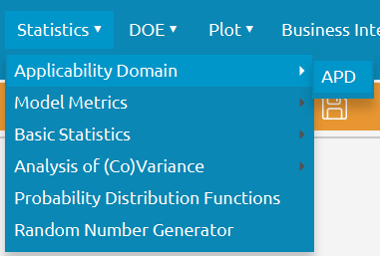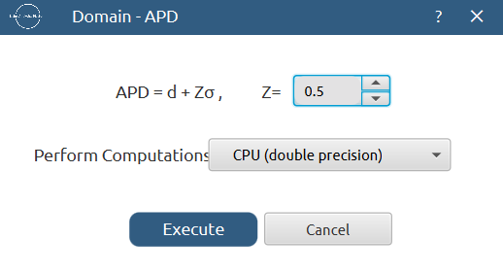

The results will appear on the output spreadsheet.
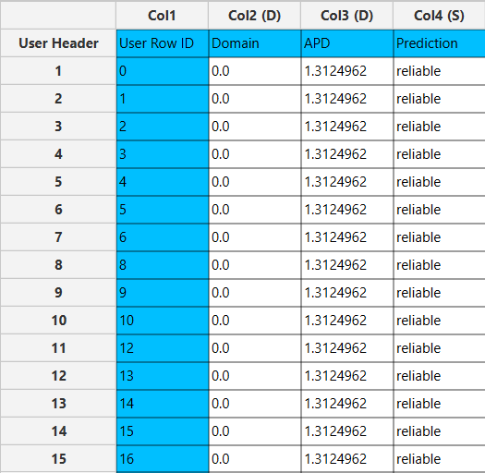

Step 12.b: Check the test set reliability
Create a new tab by pressing the “+” button on the bottom of the page with the name “EXCLUDE_CHARGES_TEST_SET”.
Import data into the input spreadsheet of the “EXCLUDE_CHARGES_TEST_SET” tab from the output of the “FEATURE_SELECTION_TEST_SET” tab by right-clicking on the input spreadsheet and then choosing “Import from Spreadsheet”.
Manipulate the data to exclude the target column “charges”: Data Transformation $→$ Data Manipulation $→$ Select Column(s)

The results will appear on the output spreadsheet.
Create a new tab by pressing the “+” button on the bottom of the page with the name “RELIABILITY”.
Import data into the input spreadsheet of the “RELIABILITY” tab from the output of the “EXCLUDE_CHARGES_TEST_SET” tab by right-clicking on the input spreadsheet and then choosing “Import from Spreadsheet”.
Check the Reliability: Analytics $→$ Existing Model Utilization$→$ Model (from Tab:) DOMAIN
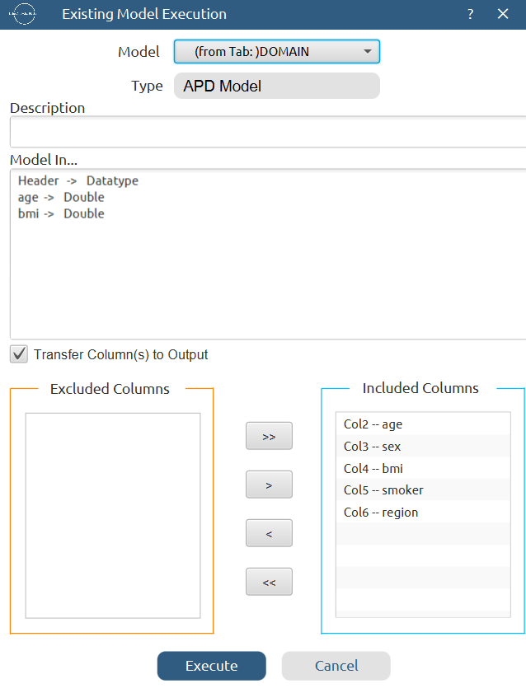

The results will appear on the output spreadsheet. There are no unreliable samples in the test set.
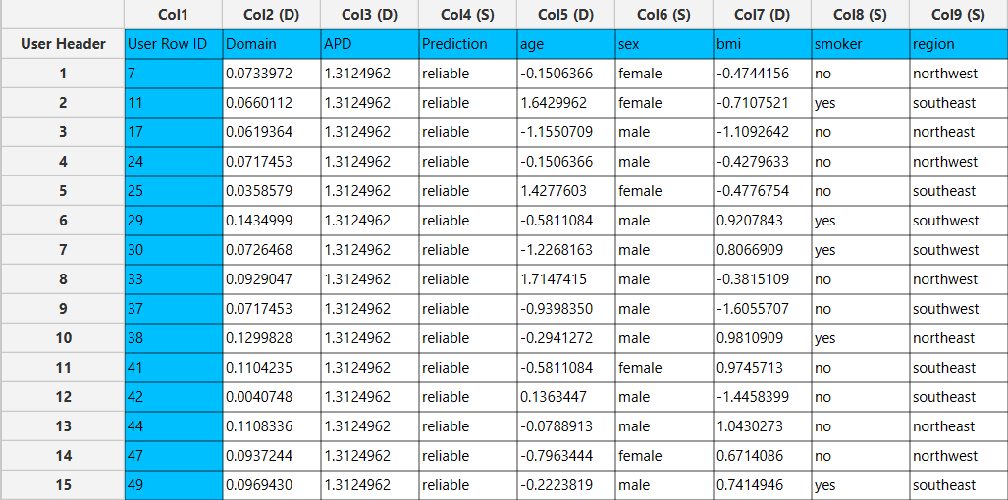

Final Isalos Workflow
Following the above-described steps, the final workflow on Isalos will look like this:
